WEEK-2

**Exercise 1: Setting Up Junit**

1. Create a new Java project in your IDE (e.g., IntelliJ IDEA, Eclipse).

Created a new maven project named junit-demo

1. Add JUnit dependency to your project. If you are using Maven, add the following to your pom.xml

In pom.xml dependency is added under dependencies

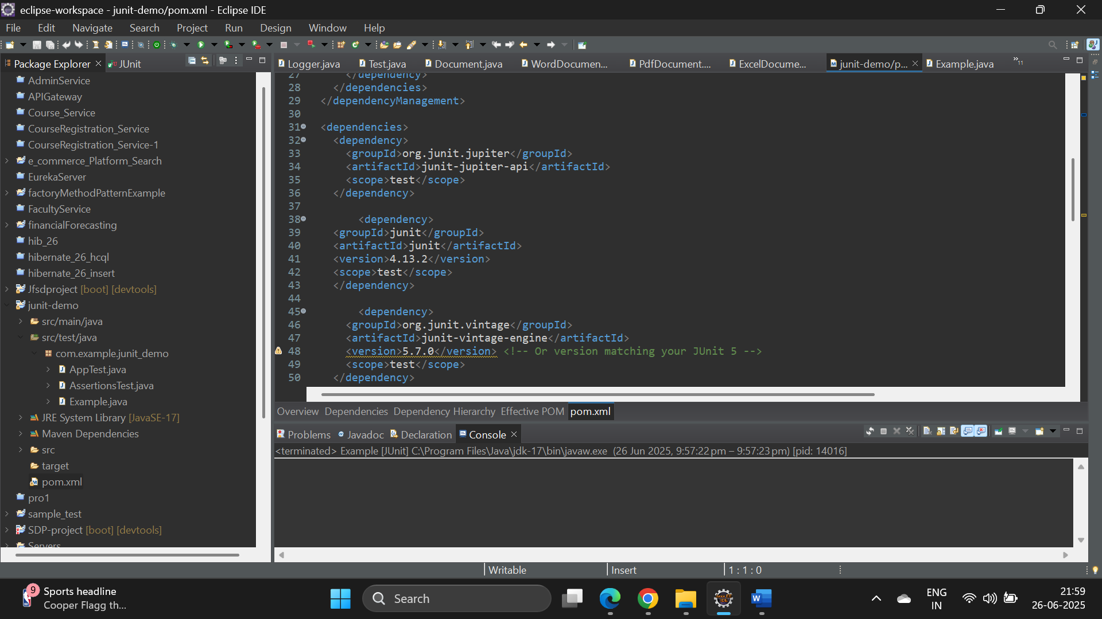

1. Create a new test class in your project.

